**Part1**

IP Address found in Collection

172.16.8.5

172.16.8.99

172.30.0.10

172.30.0.2

172.16.0.255

172.16.0.99

172.16.8.255

172.16.8.99

172.16.20.5

172.16.20.99

There are five different source IP address and six different destination address.

Using 5 different TCP port, including 21(ftp), 47395, 11383, 23(telnet), 22(ssh).

Also, using 3 different UDP port, 138, 52863, 69(tftp).

**Part 2**

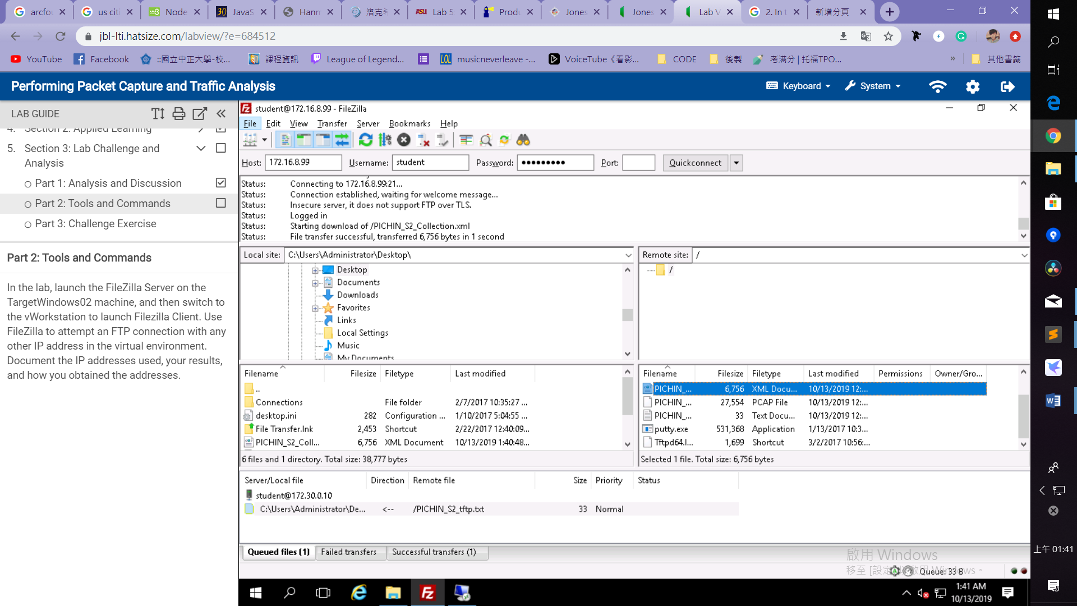

Connect to 172.16.8.99 obtained from the Collection which is an insecure server.

**Part 3**

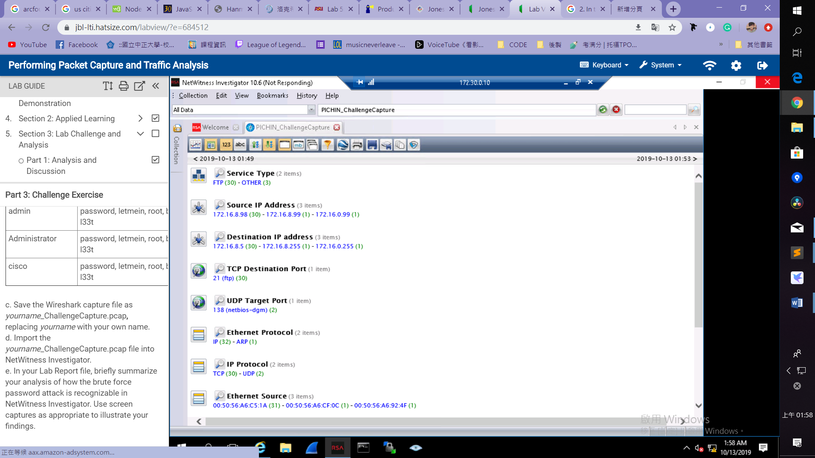

I use port 21 to connect 15 times in error passwords, and all of connection request will repeat one more time in FileZilla, so I captured 30 ftp packets between 172.16.8.98 and 172.16.8.5.

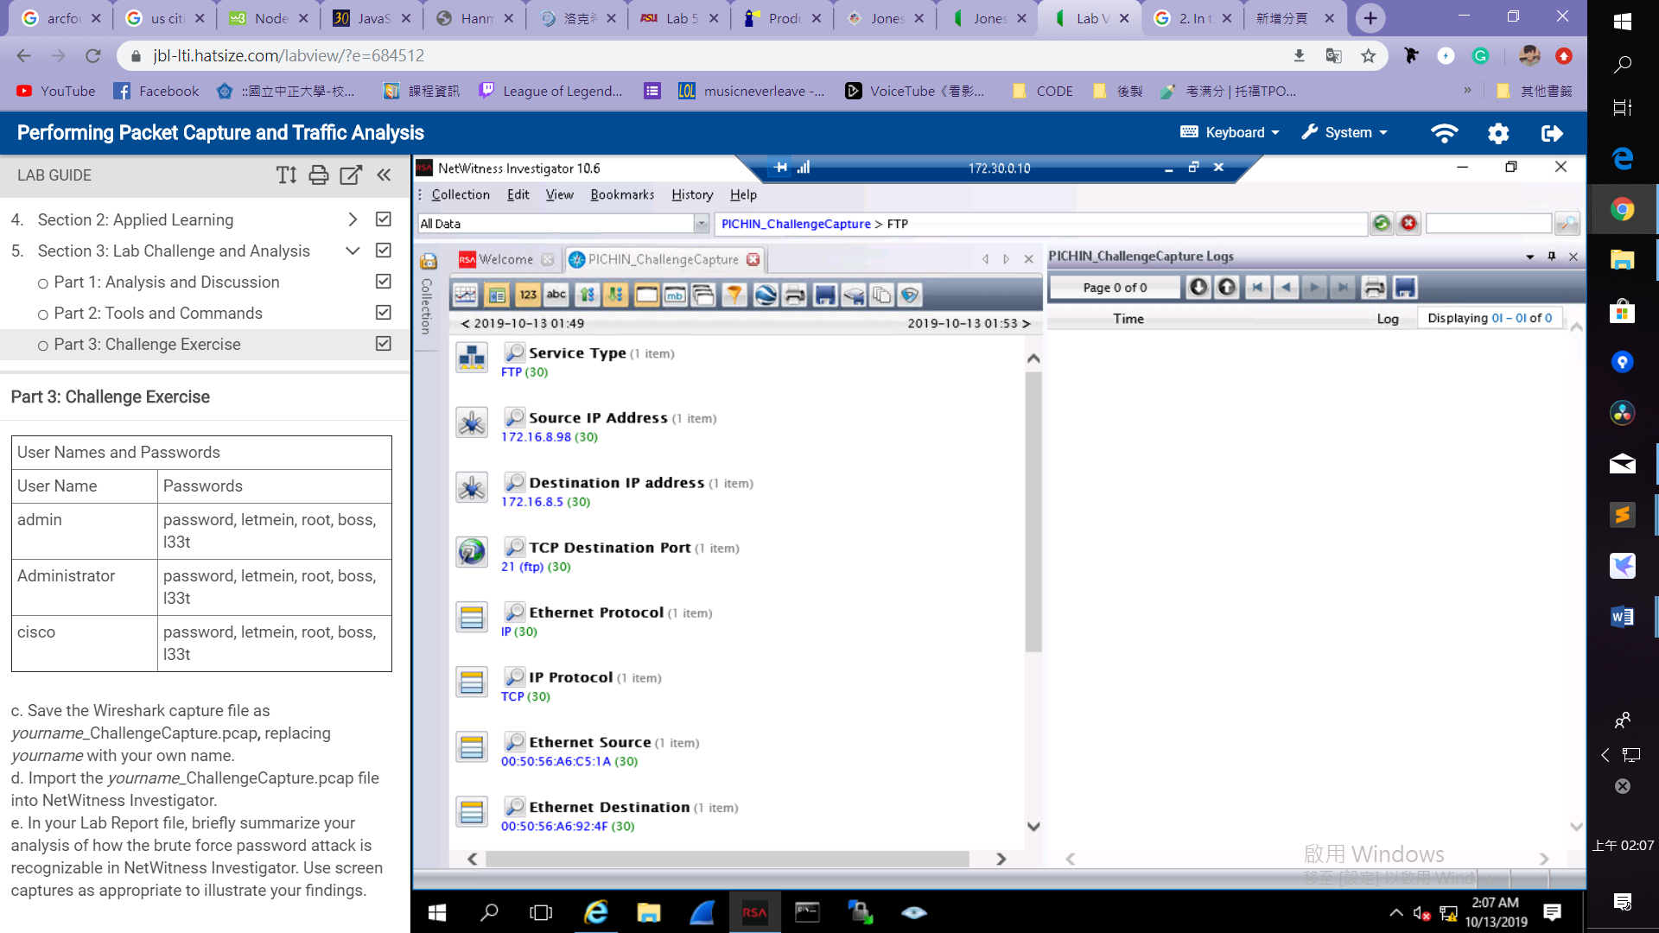 The other three packets are UDP packets delivered from 172.16.0.99 to 172.16.0.255, 172.16.8.99 to 172.16.8.255, and one ARP packet delivered from 00:50:56:A6:92:4F to FF:FF:FF:FF:FF:FF.

